Local Adaptation in Olympia Oysters: Differing Reponses in HSP70 Expression to Mild Heat Shock
By Jake Heare

Abstract
The Olympia oyster, Ostrea lurida, is the focus of many rehabilitation efforts within the Puget Sound. These efforts are ongoing but have had limited success in transplanting portions of populations to distressed areas. Many factors are involved in this problem, this study investigates the phenomenon of local adaptation as being the primary cause of transplantation issues. A significant biomarker for stress is HSP70, a common protein used to maintain protein function during stressful environmental events. Oysters are known to express HSP70 in the face of many stressors. In this study relative levels of HSP70 mRNA transcripts are used to determine the response to mild heat stress in three distinct populations from the Puget Sound. Using primers for HSP70 and Actin for PCR and qPCR this study was unable to find significant differences between populations possibly due to primer design and inadequate stressing. Future studies are suggested to determine the effects of heat stress on the many different biochemical pathways in O. lurida and are encouraged to use primers for not just HSP70 but any of the processes involved in homeostasis.
Introduction
The Olympia oyster, Ostrea lurida, has undergone many challenges in the last 100 years. Stressors from anthropogenic development of the Puget Sound, industrial waste, habitat loss, and climate change have caused population decline among Olympia oysters within the Sound (Steele et al, 1957; Rumrill, 2013). Future threats to Olympia oysters include ocean acidification and warming of surface waters in near shore areas (Miller et al., 2009; Feely et al., 2010; Hettinger et al., 2012). To combat long term dissolution of native populations in the Puget Sound, restoration efforts by government and non-profit led groups have had limited success in rehabilitating populations in distressed areas of the Sound. This study is an effort to account for these limited successes by determining biologically relevant causes for transplanted oysters’ inability to succeed in nonnative environments. A likely major phenomena to cause this is the heritable adaptation the individual oyster populations have in accordance with their specific habitat and its oceanographic properties.
Local adaptation is a phenomena in which geographically separated populations of a native species are better adapted to the habitat parameters of their specific location (Kawecki and Ebert, 2004). Many species across all taxa have shown evidence for local adaptation such as pine trees in Scandinavia (Savolainen, 2007), Brown trout in Denmark (Jensen, 2008), and copepods along the Pacific coasts (Edmands and Diemler, 2004). In each of these cases there were significant phenotypic and genomic biomarkers for adaptation such as differences in nutrient uptake and usage efficiency, lipid storage, and thermal tolerance respectively. Local adaptation allows for multiple generations of a population to have a survival advantage under local conditions versus invasive populations which may not have undergone similar natural selection (Ruesink et al, 2005). Other benefits of local adaptation are clade survival in the face of region wide habitat change such as conditions that occur during extinction events like the Paleocene-Eocene climate change event (Kitchell et al, 1986). Jablonski et al. (1986) have shown that the wider range of local adaptation that a species undergoes the higher the likelihood that a subpopulation of the species will have adapted to survive conditions similar to those during extinction events. Oyster species have shown similar effects from local adaptation (Murray and Hare, 2006). Efforts to transplant oysters from areas of high salinity to low salinity or from lighter pollution to heavier pollution have limited success. With other oyster species showing possible local adaptation it is of great interest to rehabilitation efforts for Olympia oysters to determine whether local adaptation is occurring in Puget Sound populations for both long term survival of planted oysters as well as that of native populations.
Olympia oysters have historically been harvested throughout the Puget Sound until periods of increased pollution and population mismanagement lead to depletion of the resource (Rumrill, 2013; White et al., 2009). O. Lurida is the only native oyster to the West Coast with its habitat range as far south as the Baja of Mexico and as far north as Alaska (Rumrill, 2013). From the mid 1800’s until the 1940’s they were heavily harvested for their unique flavor and texture being considered a delicacy. Severe population declines in the Puget Sound have lead their once comprehensive beds to be limited to a few bays around the Sound (White et al., 2009). O. Lurida is a cold water oyster species with most populations experiencing average temperatures between 10-20 Celsius. Within the sound average temperatures can vary between 5 degrees Celsius of each as well as experience a variety of differences in dissolved oxygen, pCO2, nutrient content, pollution, salinity, etc. Most populations have various macro and micro scale responses to stressors caused by swings in any of the conditions previously listed. Animals can close up during periods of low oxygenation and high pCO2 as well increased feeding efforts to offset energy usage for maintaining homeostasis (Timmins-Shciffman, 2013). On the micro scale these animals have developed an impressive array of molecular mechanisms to combat stressors. In other species there is extensive evidence for changes in these molecular mechanisms to adapt to location specific stressor profiles that may or may not be effective when transplanted to new areas.
Many cellular mechanisms are modified through selection events in native populations which lead to organisms that survive stressor conditions in specific locations. Animals such as Copepod ss. have developed differences in isoforms of the HSP70 protein in relation to whether they live in tidal pools versus nearshore waters. Brown algae have shown differences in expression in copper toxicity related enzymes due to adaptation to local conditions (Ritter et al., 2009) Other mechanistic adaptations include changes to phosphoglucose isomerase in California montane beetles in response to variations in regional differences in seasonal temperatures and food availability (Dahlhoff, 1999) Bivalves have shown similar acclimation events. The Mytilus sp. have developed several phenotypic and genetic differences along the Atlantic coastlines leading to possible speciation events (Riginos and Cunningham, 2004) Possible adaptions for Olympia oysters could be related to being able to handle the relatively warmer water of Southern bays versus those in cooler temps in the areas around the Strait of Juan de Fuca.
Heat shock proteins are homeostatic molecular mechanisms that help cells maintain proper protein folding under thermal stress (Feder and Hofman, 1999). HSP70 is considered the most conserved form and has functions far beyond just protein refolding such as heat shock priming and cell growth and development (Sorenson, 2003). Many species have presented with heat shock proteins such as copepods (Edmands and Deimler, 2004), mussels (Riginos and Cunningham, 2005), killifish (Fangue et al., 2006; Schulte, 2007), and oysters (Elise, 2005; Timmins-Schiffman, 2013) Heat shock priming is of high importance in the face of thermal shock as primed cells have higher survival rates than those with no priming. The priming functions of HSP70 including creating Heat Shock Factors that act as targets for transcription on necessary cell maintenance genes as well as increasing production of more HSP70 proteins. Studies have shown that native species will be better primed for thermal stress than non native species of kelp (Henkel and Hofmann, 2008). Increased concentration of HSP70 proteins can also prime the cell by being more available to deal with denaturation events that occur during thermal shock. The priming effects of HSP70 have been shown to occur at sub lethal temperatures and could be used as indicators for local adaptation differences between populations (Fangue et al, 2006). If a population is better adapted to warmer temperatures, slight temperature (<10 C increase) increases should illicit very little response from HSP70 mRNA transcripts. Whereas populations less tolerant to warmer temperatures might have a disproportionate response to slight temperature increases.
Using previously verified RNA isolation techniques, this study will use in situ mRNA concentrations for HSP70 transcripts to determine whether slight increases in temperature illicit strong or weak reactions from offspring of populations from 3 geographically distinct locations within the Puget Sound. mRNA transcripts will be converted to cDNA through the use of reverse transcriptase. cDNA will then be used to perform PCR tests to determine presence of HSP70 transcripts and qPCR tests will determine the relative abundance of HSP70 transcripts between populations and time points. From this information we will be able to deduce whether geographically distinct populations have significantly different reactions to sub lethal heat stress caused by selection leading to local adaptation amongst these populations.
Materials/Methods
Olympia oysters bred over summer 2013 from populations in Fidalgo Bay (Northern Sound), Dabob Bay (Hood Canal), Oyster Bay (South Sound) were collected at Port Gamble, WA on November 1st. Ten juvenile oysters from each population were then acclimated to 12 C temperatures for 1 week in cold storage (10-14 C) and fed 30-60 million cells of phytoplankton from Commercial Shellfish Diet once every 24 hours. After one week 5 animals were randomly removed from each population and the temperature was raised over the period of 3 hours to 24 C in the tank.Remaining oysters were fed a final time then at roughly 24 hours, the 5 animals from each population were sampled.
Sample preparation was done as follows. Animals were patted dry and then measures for length. Under sterile conditions and with the use of a flame sterilizer, the animals were opened and a 25-250 ug portion of whole body tissue was dissected out into 1.5 ul RNase free tubes. Samples were placed on dry ice for flash freezing and weighed after all samples were collected TriReagent (500 ul) was added to the tissue samples and they were homogenized with a plastic pestle for 30 seconds to 1 minute. Samples were stored at -80 C until RNA isolation could be performed.
RNA Isolation
Samples were allowed to thaw to room temperature and another 500 ul of TriReagent was added to each tube then vortexed. Chloroform (200 ul) was added to each tube followed by more vortexing and a 5 minute incubation at room temperature. Samples were centrifuged at 4C for 15 minutes at 16.1 relative centrifugal force (rcf). The clear portion on top was then extracted and placed in fresh RNase Free tubes with Isopropanol (500 ul) followed by vortexing and a 10 minute incubation at room temperature. Samples were then centrifuged at 4C for 8 minutes at 16.1 rcf and supernatant wastes were removed from the pelleted material. Ethanol (EtOH 75% 1 ml) was added to the sample for salt cleansing followed by vortexing and being centrifuged at 4C for 5 minutes at 7.5 rcf. The supernatant waste was again removed and eliminated. Samples were then briefly centrifuged to pool excess EtOH remaining in the sample which was drawn out by pipetting. Samples were then air dried for 5 minutes under a hood and resuspended using 0.1% DEPC H2O (100 ul), incubated at 55 C for 5 minutes, vortexed, and then stored at -80 C.
Quantification/cDNA creation
Samples were quantified using a Nanodrop with sample concentrations ranging between 3600-4000 ng/ul. Using the isolated RNA, cDNA was created to do PCR and qPCR with. cDNA was created using the following protocol. In 0.5 ml tubes Nuclease Free H20 (4 ul), oligo DT (1 ul), and RNA (5 ul) were vortexed together and incubated at 70 C for 5 minutes then transferred immediately to ice. A master max of the following reagents was created; MMLV 5X Reaction Buffer (5 ul), dNTP (5 ul), MMLV Reverse Transcriptase (1 ul), and Nuclease Free H20 (4 ul). Master Mix (15 ul) was added to each 0.5 ml tube. Samples were then incubated at 42 C for 60 minutes followed by a temperature increase to 70 C for 3 minutes. Finally, samples were spun down and stored at -80 C.
Conventional PCR
Primers for HSP70 in Crassostrea gigas and Actin in O. lurida were previously designed by other students. The HSP70 primer set (GTTCCGATTTGTTCCGTGCC; TTGTCGCCATTTTCCTCGCT) was designed in Ostrea edulis (AF416609.1) an HSP70 mRNA from gill and expected product size of 20( bp. The Actin primer set (GACCAGCCAAATCCAGACGA; CGGTCGTACCACTGGTATCG) was developed for O. lurida adductor muscle from Roberts Lab sequence data and expected to be 113 bp. A Master Mix of goTaq Green (12.5 ul), 1 nM Forward Primer (1 ul), 1 nM Reverse Primer (1 ul) was created and then added in 14.5 ul volumes to PCR tubes. cDNA (1 ul) was added as well as Nuclease free water (9.5 ul). PCR program was as follows: 2 minutes at 95 C for initial denaturation, then for duplication steps 45 seconds at 95 C, 45 seconds at 54 C, and 2 minutes at 73 C for 31 cycles, and a final extension step at 74 C for 5 minutes. Samples were held overnight at 4 C until a 1.3% agarose gel could be run.
Gel Electrophoresis
To make a 1.3% agarose gel, 25X TAE (7 ml) was added to Nanopure H2O (175 ml). Standard agarose (2 g) was mixed into the TAE and microwaved for 2 minutes 30 seconds with a 30 second swirl, then another 30 seconds in the microwave. Gel was allowed to cool and EtBr (17.5 ul) added to the solution then poured quickly into a gel casting tray with 20 well comb. Running gel was cooled to room temperature, placed in electrophoresis box, and covered with 1X TAE (750 ml). The wells were filled with either ladder (5 ul) or PCR samples (12.5 ul). It was then ran at 100v for 40 minutes and checked frequently to make sure the loading dies separated evenly across the gel. After completing the gel run, the gel was then illuminated on a transilluminator in a darkened room to determine whether replication had occurred.
Quantitative PCR
Wells of a qPCR tray were loaded with Ssofast Evagreen MM (10 ul), Nuclease Free H20 (8 ul), Forward Primer (0.5 ul), Reverse Primer (0.5 ul), and cDNA (1 ul). qPCR tray was loaded into the BioRad Opticon 2 qPCR machine and used a preset program for SYBR dye [95 C, 10 min; 95 C, 15 sec; 55 C, 15 sec; Read; 72 C, 15 sec; Read; Repeat steps 2-5 39 times; 95 C, 1 min; Start at 55C increase 0.2 C every second; Melt Curve 65 C to 95 C Read 0.5 sec, Hold 30 sec; 21 C 10 min] After 2 hours 10 minutes the reads were finalized, replication curves and melt curves were designated by the opticon 2 programming.

Results
PCR product for the HSP70 transcript had strong single bands for each sample at the 200 base pair (bp) region of the ladder as seen in Figure 1. This was close to the expected band size of 208 bp. With no banding in the control (lane left of ladder)
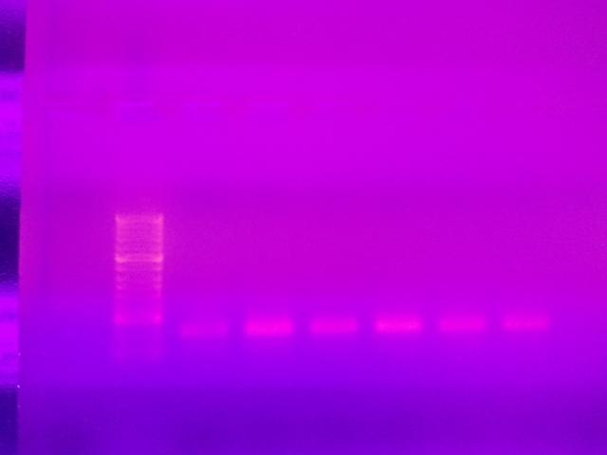
Figure 1. HSP70 primer PCR products in 1.3% agarose gel with EtBr. 5 ul of Ladder, 12.5 ul of PCR sample in each well. To the left of the ladder is the negative control, to the right samples are as follows: NO1, N241, SO1, S241, HO1, H241. Gel run at 100v for 40 minutes. Visualized using Transilluminator
The PCR product for Actin had strong banding at 100 bp marker on the ladder for Actin primer as seen in Figure 2. This band size was close to the expected band size of 113 bp. There was no banding in the control (lane left of the ladder).
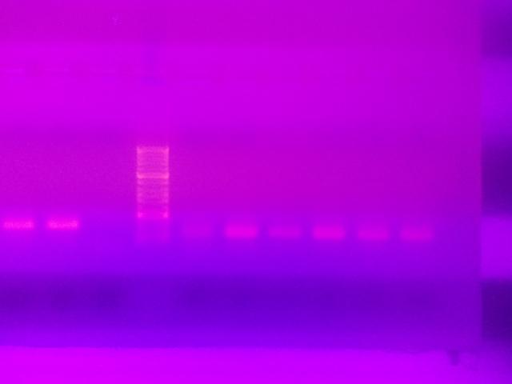Figure 2. Actin primer PCR products in 1.3% agarose gel with EtBr. 5 ul of Ladder, 12.5 ul of PCR sample in each well. To the left of the ladder is the negative control, to the right samples are as follows: NO1, N241, SO1, S241, HO1, H241. Gel run at 100v for 40 minutes. Visualized using transilluminator.
These products met the expectations for size and band strength which promoted a follow up trial using the qPCR machine. qPCR results had both primers appearing to replicate in the cycle period (cycle 25-30 out of 39 for most samples) as seen in Table 1.

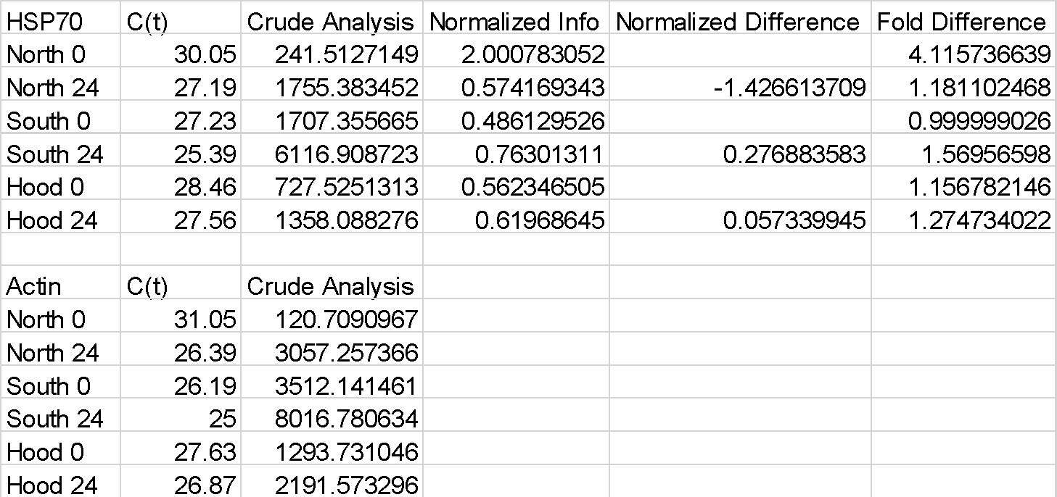
Table 1. Results from qPCR run. C(t) is the cycle in which exponential amplification occurs. Crude analysis was done by entering the C(t) value into the equation =10^(-(0.3012*C(t))+11.434) to roughly estimate the number of transcripts of interest from the sample. Normalized values were the HSP70 estimate divided by the Actin estimate. Normalized difference is the normalized value for time point 24 subtracted by the normalized value for time point 0. Fold difference is the Normalized values divided by the lowest normalized value in the set.
Amplification and Melt Curves for both primers looked good with smooth amplification for both primers and no amplification in the negative controls as seen in Figure 3 and 4.
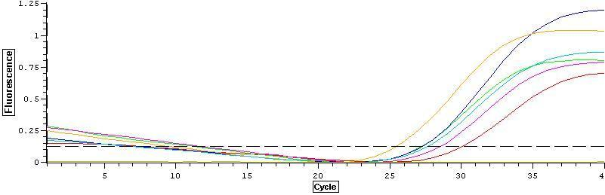Figure 3. HSP70 amplification curve
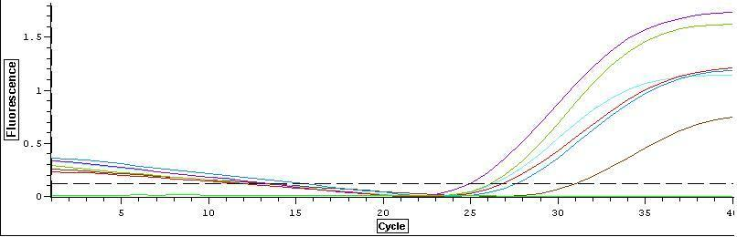Figure 4. Actin Amplification Curve
Melt curves had a single peak for the products in each sample which suggested that only one target was amplified as seen in Figures 5 and 6.
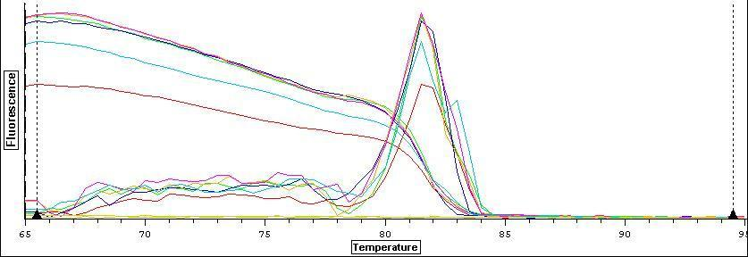Figure 5. HSP Melt Curve
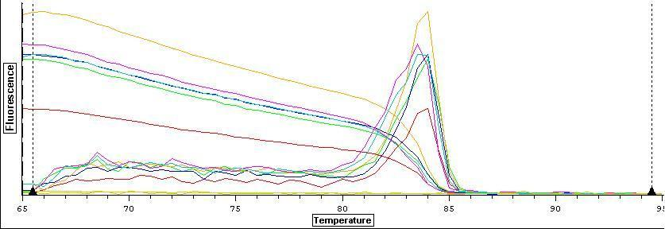Figure 6. Actin Melt Curve
There seemed to be some difference between time points in each population with the Northern populations decreasing in number of transcripts while the Southern and Hood Canal populations increased slightly. Normalized values were graphed in Figure 7 for direct comparison.
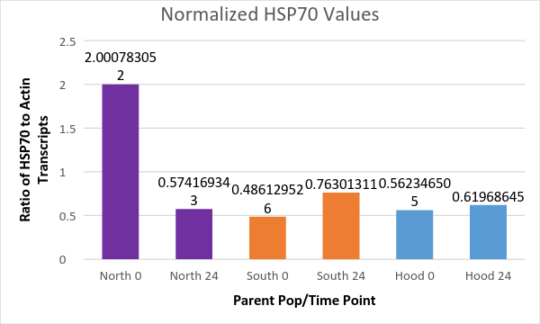
Figure 7. Normalized HSP70 values for each population at each time point.

Discussion
From the conventional PCR, the presence of HSP70 and Actin transcripts were confirmed in all samples while no contamination or errant amplification occurred in the negative control. From the base pair size of the band in each gel as compared to the expected size we can safely say that both transcripts amplified the intended target without indiscriminate amplification. It should be noted that fluorescence intensity in sample NO1 was relatively diminished in both HSP70 and Actin which could be a sign of fewer transcripts, sample degradation, or PCR error. Unlike NO1, SO1 showed a relatively diminished fluorescence intensity with the Actin primer but not with the HSP70 primer. This might be due to a concentration difference between transcripts within the sample.
While only one sample from each population at each time point was used we were able to find a trend in the data that could be of interest. The northern population at time zero had nearly 4 times the transcripts of HSP70 to Actin which compared to the other populations normalized values was about a 4 fold difference (as seen in Table 1 under fold difference). At the 24 hour mark for the Northern population, the HSP70 transcripts dipped back to normal levels at 1/4th the strength seen in the time point 0 sample. It is possible that the Northern populations are adapted for drastically cooler temperatures in the Strait of Juan de Fuca and the initial acclimatization temperature was actually too high for them causing a stress event. After the short period of mild heat stress, the animals were over taxed and stopped producing HSP70 transcripts. One possible reason for this is that the animals began processing transcripts for cell death instead of trying to mitigate protein denaturation. Further tests for Caspase and peroxidase related transcripts could determine if the animals had begun cell death functions.
As for the other two populations, in the Southern animals we say a 1.5 fold increase in transcripts at time point 24 and in the Hood Canal animals we only saw a 1.1 fold increase. The difference between these two populations is small but it is possible that animals in Dabob bay undergo far more heat stress on a regular basis due to the differing tidal patterns that expose rock bottom animals to warmer temperatures for longer periods. This would mean that any mild heat stress would activate only the most minimal of HSP70 responses. Southern animals exist in a muddy bottom of Oyster Bay with much more regular tides and may not experience similar periods of heat stress as compared to animals within Dabob bay. Overall more replicates for all populations and time points need to be run to determine if these preliminary trends hold true.
Using mRNA transcripts for markers of local adaption are somewhat limited and can be easily swayed by concentration issues or processing problems. Final results from this study should not be considered as positive or negative results for local adaption but instead be used to better understand the short falls of using such sequences so that future work may benefit from the mistakes and missteps made here. If samples from this experiment are re-used in the future there are two definite issues that need to be resolved. 1) More primers need to be generated and validated for future work, including primers for other stress related pathways such as glycogen metabolism, cell death, ubiquitinization, and other forms of heat shock primers. 2) DNase treatment of RNA isolation needs to occur to prevent errant DNA transcript from contaminating samples with excess target genes. While I think that sublethal and mild heat shock are key in elucidating possible regulation differences among populations it is possible that temperature change in this study was too low to elucidate a significant response in any population and in future studies will need to be more excessive in the future.
This pilot study is part of a larger study to determine the effects of localization on Olympia oysters. While the information from this study is preliminary it is hoped that more samples can be run in the future to generate data about how disparate populations deal with subtle changes in the environment. It is suggested that future primers include other biochemical pathways such as those for glycogen metabolism, growth, cell damage, and cell death to help bolster any findings from future genomic and epigenomic work on oysters.

References
Dahlhoff, Elizabeth P., and Nathan E. Rank. “Functional and Physiological Consequences of Genetic Variation at Phosphoglucose Isomerase: Heat Shock Protein Expression Is Related to Enzyme Genotype in a Montane Beetle.” Proceedings of the National Academy of Sciences 97, no. 18 (August 29, 2000): 10056–10061. doi:10.1073/pnas.160277697.
Edmands, Suzanne, and Julie K. Deimler. “Local Adaptation, Intrinsic Coadaptation and the Effects of Environmental Stress on Interpopulation Hybrids in the Copepod Tigriopus Californicus.” Journal of Experimental Marine Biology and Ecology 303, no. 2 (June 8, 2004): 183–196. doi:10.1016/j.jembe.2003.11.012.
Fangue, Nann A., Myriam Hofmeister, and Patricia M. Schulte. “Intraspecific Variation in Thermal Tolerance and Heat Shock Protein Gene Expression in Common Killifish, Fundulus Heteroclitus.” Journal of Experimental Biology 209, no. 15 (August 1, 2006): 2859–2872. doi:10.1242/jeb.02260.
Feder, Martin E., and Gretchen E. Hofmann. “HEAT-SHOCK PROTEINS, MOLECULAR CHAPERONES, AND THE STRESS RESPONSE: Evolutionary and Ecological Physiology.” Annual Review of Physiology 61, no. 1 (1999): 243–282. doi:10.1146/annurev.physiol.61.1.243.
Feely, Richard A., Simone R. Alin, Jan Newton, Christopher L. Sabine, Mark Warner, Allan Devol, Christopher Krembs, and Carol Maloy. “The Combined Effects of Ocean Acidification, Mixing, and Respiration on pH and Carbonate Saturation in an Urbanized Estuary.” Estuarine, Coastal and Shelf Science 88, no. 4 (August 10, 2010): 442–449. doi:10.1016/j.ecss.2010.05.004.
Henkel, Sarah K., and Gretchen E. Hofmann. “Differing Patterns of hsp70 Gene Expression in Invasive and Native Kelp Species: Evidence for Acclimation-Induced Variation.” Journal of Applied Phycology 20, no. 5 (October 1, 2008): 915–924. doi:10.1007/s10811-007-9275-3.
Hettinger, Annaliese, Eric Sanford, Tessa M. Hill, Ann D. Russell, Kirk N. S. Sato, Jennifer Hoey, Margaux Forsch, Heather N. Page, and Brian Gaylord. “Persistent Carry-over Effects of Planktonic Exposure to Ocean Acidification in the Olympia Oyster.” Ecology 93, no. 12 (June 14, 2012): 2758–2768. doi:10.1890/12-0567.1.
Jablonski, David. “Background and Mass Extinctions: The Alternation of Macroevolutionary Regimes.” Science 231, no. 4734 (January 10, 1986): 129–133. doi:10.1126/science.231.4734.129.
Jensen, Lasse Fast, Michael M. Hansen, Cino Pertoldi, Gert Holdensgaard, Karen-Lise Dons Mensberg, and Volker Loeschcke. “Local Adaptation in Brown Trout Early Life-History Traits: Implications for Climate Change Adaptability.” Proceedings of the Royal Society B: Biological Sciences 275, no. 1653 (December 22, 2008): 2859–2868. doi:10.1098/rspb.2008.0870.
Kawecki, Tadeusz J., and Dieter Ebert. “Conceptual Issues in Local Adaptation.” Ecology Letters 7, no. 12 (2004): 1225–1241. doi:10.1111/j.1461-0248.2004.00684.x.
Kitchell, Jennifer A., David L. Clark, and Andrew M. Gombos. “Biological Selectivity of Extinction: A Link between Background and Mass Extinction.” PALAIOS 1, no. 5 (October 1, 1986): 504–511. doi:10.2307/3514632.
Miller, A. Whitman, Amanda C. Reynolds, Cristina Sobrino, and Gerhardt F. Riedel. “Shellfish Face Uncertain Future in High CO2 World: Influence of Acidification on Oyster Larvae Calcification and Growth in Estuaries.” PLoS ONE 4, no. 5 (May 27, 2009): e5661. doi:10.1371/journal.pone.0005661.
Riginos, C, and C W Cunningham. “Local Adaptation and Species Segregation in Two Mussel (Mytilus Edulis X Mytilus Trossulus) Hybrid Zones.” Molecular Ecology 14, no. 2 (February 2005): 381–400. doi:10.1111/j.1365-294X.2004.02379.x.
Ritter, Andrés, Martin Ubertini, Sarah Romac, Fanny Gaillard, Ludovic Delage, Aaron Mann, J. Mark Cock, Thierry Tonon, Juan A. Correa, and Philippe Potin. “Copper Stress Proteomics Highlights Local Adaptation of Two Strains of the Model Brown Alga Ectocarpus Siliculosus.” PROTEOMICS 10, no. 11 (2010): 2074–2088. doi:10.1002/pmic.200900004.
Ruesink, Jennifer L., Hunter S. Lenihan, Alan C. Trimble, Kimberly W. Heiman, Fiorenza Micheli, James E. Byers, and Matthew C. Kay. “Introduction of Non-Native Oysters: Ecosystem Effects and Restoration Implications.” Annual Review of Ecology, Evolution, and Systematics 36 (December 31, 2005): 643–689.
Rumrill, Steve. “Natural History, Geographic Distribution, Status, and Life-Cycle of Olympia Oysters (Ostrealurida).” Oregon Institute of Marine Biology, September 2013.
Savolainen, Outi, Martin Lascoux, and Juha Merilä. “Ecological Genomics of Local Adaptation.” Nature Reviews Genetics 14, no. 11 (November 2013): 807–820. doi:10.1038/nrg3522.
Savolainen, Outi, Tanja Pyhäjärvi, and Timo Knürr. “Gene Flow and Local Adaptation in Trees.” Annual Review of Ecology, Evolution, and Systematics 38, no. 1 (2007): 595–619. doi:10.1146/annurev.ecolsys.38.091206.095646.
Schulte, Patricia M. “Responses to Environmental Stressors in an Estuarine Fish: Interacting Stressors and the Impacts of Local Adaptation.” Journal of Thermal Biology 32, no. 3 (April 2007): 152–161. doi:10.1016/j.jtherbio.2007.01.012.
Sørensen, Jesper Givskov, Torsten Nygaard Kristensen, and Volker Loeschcke. “The Evolutionary and Ecological Role of Heat Shock Proteins.” Ecology Letters 6, no. 11 (2003): 1025–1037. doi:10.1046/j.1461-0248.2003.00528.x.
Timmins-Schiffman, Emma B., Carolyn S. Friedman, Dave C. Metzger, Samuel J. White, and Steven B. Roberts. “Genomic Resource Development for Shellfish of Conservation Concern.” Molecular Ecology Resources 13, no. 2 (2013): 295–305. doi:10.1111/1755-0998.12052.
Timmins-Schiffman, Emma, Brook L. Nunn, David R. Goodlett, and Steven B. Roberts. “Shotgun Proteomics as a Viable Approach for Biological Discovery in the Pacific Oyster.” Conservation Physiology 1, no. 1 (January 1, 2013): cot009. doi:10.1093/conphys/cot009.
White, J., J. L. Ruesink, and A. C. Trimble. “The Nearly Forgotten Oyster: Ostrea Lurida Carpenter 1864 (Olympia Oyster) History and Management in Washington State.” Journal of Shellfish Research 28, no. 1 (2009): 43–49. doi:10.2983/035.028.0109.

